Assignment-1-Team-19

Team members: Anannya Chatterjee, Tejasvi Meka

2-39(a)

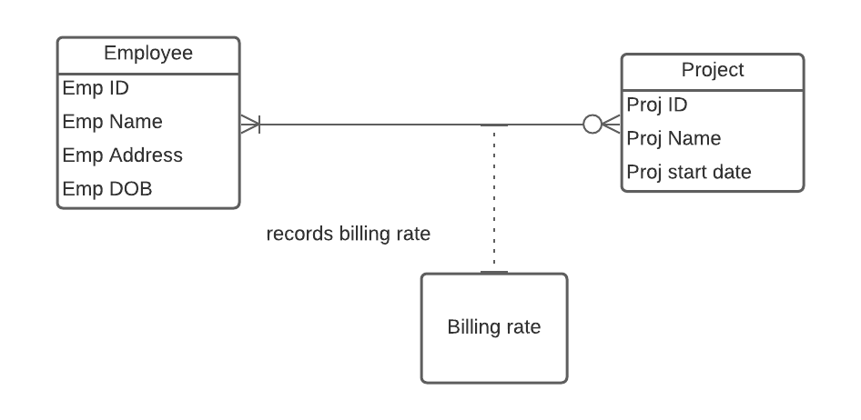

**Fig**2-39(a) ERD

**Primary Keys**: We are describing the Primary keys of the Employee entity and the Project entity here. **Emp ID is the PK of Employee entity and Proj ID is the PK of the Project entity**.

**Relationships and Cardinalities:**

Each employee is assigned to zero or many projects and

Each project has minimum one employee or many employees assigned.

**Billing rate Entity:**

It is the associative entity on our ERD. Since there exists a many to many Relationship between Employee and Project entities, so there exists an associate entity in the Entity Relationship Diagram.

The “Billing rate” entity will have Emp ID and Proj ID from the Employee and Project entities respectively. These are the Foreign keys here as these are the Primary Keys in Employee and Project entities respectively.

2-39(b)

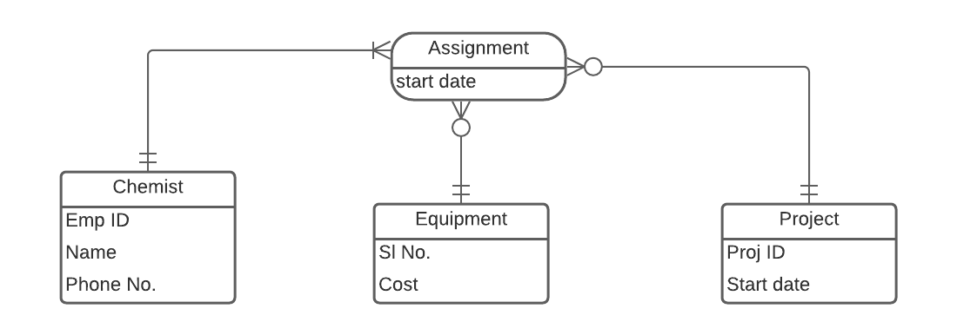

**Fig**2-39(b) ERD

**Primary Key, Foreign key**: We are describing the Primary key, foreign key and other attributes of the Chemist, Equipment and the Project entity.

Here, the attributes of ‘CHEMIST’ include **Employee ID (Primary key)**, Name, and Phone No. Attributes of PROJECT include **Project ID (Primary key)** and Start Date. Attributes of EQUIPMENT include **Serial No (Primary key)** and Cost. The associative entity is “Assignment” which has ‘Start date’ as one of its attributes.

**Relationships and Cardinalities:**

One Chemist must be assigned to at least one project and one equipment item.

One Equipment may or may not get assigned to any chemist.

One Project may or may not get assigned to either a chemist or an equipment.

**Assignment Entity:**

All three entities participate in the Assigned relationship that is modeled as an

associative entity Assignment. Since the Assign Date for each CHEMIST’s assignment to a

particular project and equipment item must be tracked, so this Assignment entity will help us to do that in our ERD.

‘Start date’ is an attribute of this Assignment Entity. Also, EQUIPMENT and PROJECT

do not need to participate in any assignments.

2-39(c)

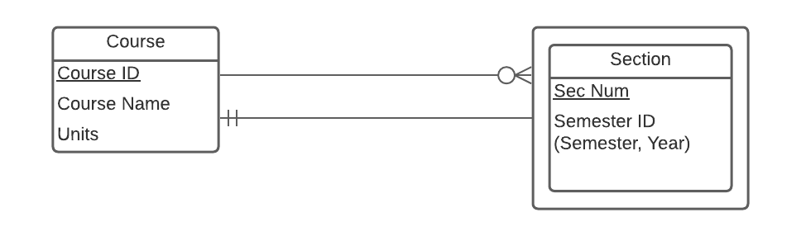

**Fig**2-39(c) ERD

**Primary Key**: We are describing the Primary key and other attributes of the Course and Section entity.

Here, the attributes of ‘Course’ include **Course ID (Primary key),** Course Name and Units. Attributes of Section include **Sec Num (Primary key)** and Semester ID.

**Relationships and Cardinalities:**

One course can have zero or many sections.

Each section will have mandatory only one course.

2-39(d)

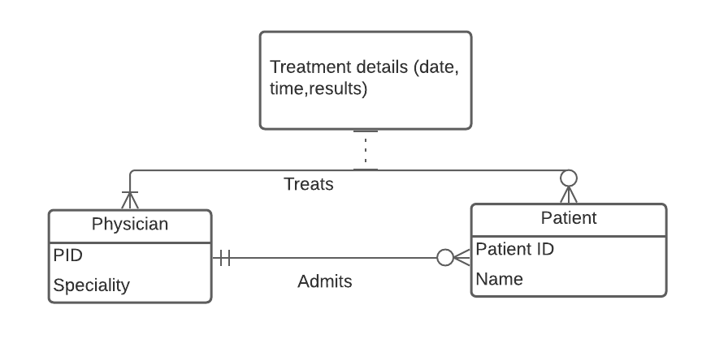

**Fig**2-39(d)(1) ERD

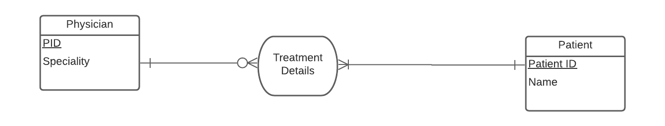

**Fig**2-39(d)(2) ERD

**Primary Key, Foreign key**: We are describing the Primary key, foreign key and other attributes of the Physician and Patient entity.

Here, the attributes of ‘Physician’ entity include **PID (Primary key)** and Speciality. Attributes of ‘Patient’ entity include **Patient ID (Primary key)** and Start Date.

**Relationships and Cardinalities:**

Here cardinalities described as:

Each physician admits zero or many patients.

Each patient will be admitted by only one physician (mandatory).

And here treatment details are recorded as:

Each physician may treat zero or many patients.

Each Patient must be treated by at least one physician.

The **Fig**2-39(d)(1) ERD could also be revised to show TREATMENT DETAIL associative entities (with corresponding attributes) to depict the M:N relationships between Patients and Physicians. That is captured in **Fig**2-39(d)(2) ERD.

**Treatment Details Entity:**

The two entities participate in the Treats relationship that is modeled as an

associative entity ‘Treatment Details’. This entity will help us to record the details of the treatment. This associative entity would have ‘Date, Time, Results’ as its attributes.

2-39(e)

**First situation**: Credit check can be used by more than one request.

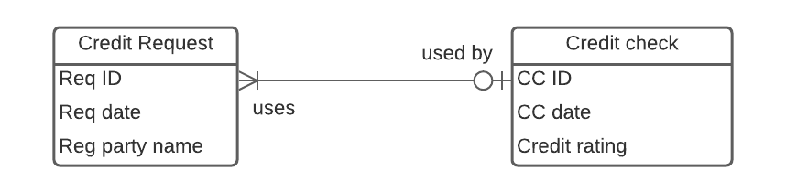

**Fig**2-39(e)(1) ERD

**Primary keys**: Req ID(Request ID) from Credit Request entity is the primary key.

CC ID (Credit check ID) from Credit check entity is the primary key.

**Relationships and Cardinalities:**

One Credit check can be used by more than one Credit request.

One Credit request may not use or maximum use one credit check.

**Second Situation**: Credit check can only be used by 1 credit request – It involves 2 Entities.

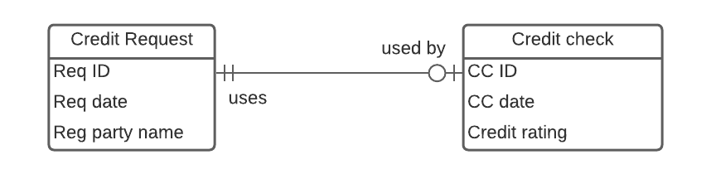

**Fig**2-39(e)(2) ERD

**Second Situation**: credit check can only be used by 1 credit request – It involves only 1 Entity.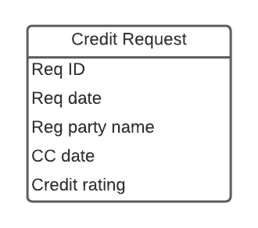

**Fig**2-39(e)(3) ERD

2-39(f)

**Initial diagram:**

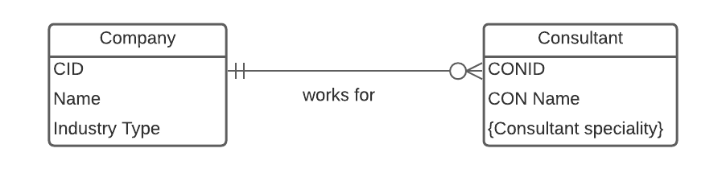

**Fig**2-39(f)(1) ERD

**Primary Key: CID (Company ID)** from Company entity

**CONID (Consultant ID)** from Consultant entity

**Company and Consultant entities:** The cardinality described here is:

One consultant works for one and only one company.

One company may hire multiple consultants.

Now, considering situations.

Situation 1 – Adding Hourly Rate attribute. which is the rate a consultant charges a company

for each hour of his or her services. Following the business rule that one consultant works for only one company at a time, hourly rate attribute could be added to the consultant entity. Below is the diagram.

.

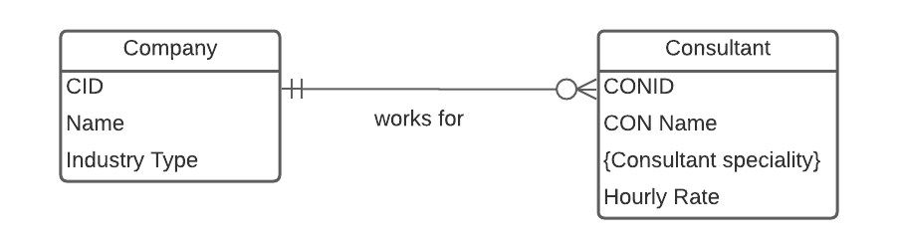

**Fig**2-39(f)(2) ERD

**Primary Keys**: **CID (Company ID)** from company entity

**CONID (Consultant ID)** from consultant entity. Hourly rate is added as an attribute to this entity.

Situation 2**:**

**Company and Contract entities:** Each time one consultant works for a company, a contract is written describing the terms for this consulting engagement. We have moved Hourly rate to Contract entity since this permits a Consultant to vary his/her hourly rate based on contract for a company.

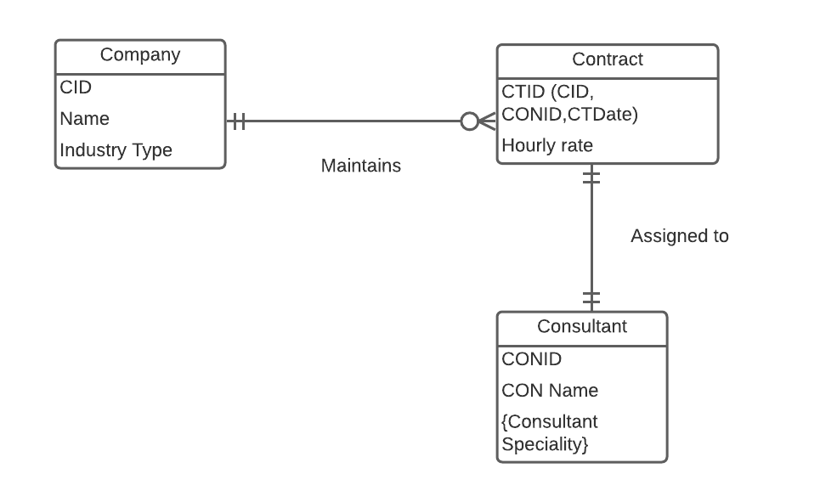

**Fig**2-39(f)(3) ERD

**Primary Keys**: CID(Company ID) from company entity

CONID(Consultant ID) from consultant entity

CID, CONID(composite primary key) from contract entity

**Foreign Key**: CID(Company ID) and CONID(Consultant ID) are Foreign keys in Contract Entity.

**Relationships and Cardinalities:**

**Contract and Consultant entities:**

One company may maintain zero or many contracts.

One contract is maintained by one and only one company.

**Contract and Consultant entities:** Here cardinality described as mandatory one contract is assigned to mandatory one consultant and vice versa.

**Situation 3 –**For tracking all the historical CONTRACT information for all consultants and all companies, Contract entity is made as associate entity.

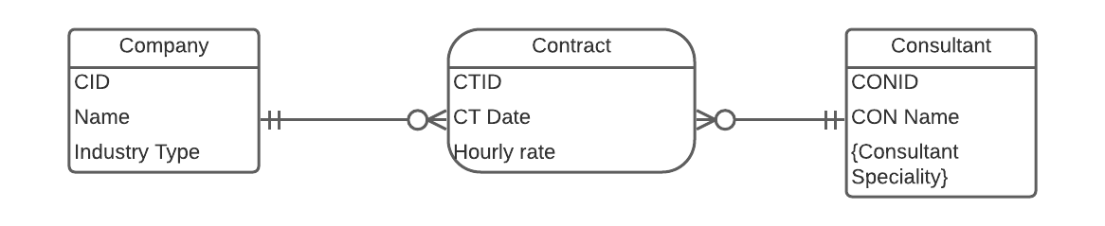

**Fig**2-39(f)(4) ERD

**Primary Keys**: CID (Company ID) from Company entity

CONID (Consultant ID) from Consultant entity

CTID (Contract ID) from contract entity

**Relationships and Cardinalities:**

**Company and Contract entities:** Here cardinality is explained as One Company maintains zero or many contracts. One contract is maintained by only one company.

**Contract and Consultant entities:** Here cardinality is explained as one consultant has worked on zero or many contracts. One contract is assigned to one and only one Consultant

2-39(G)

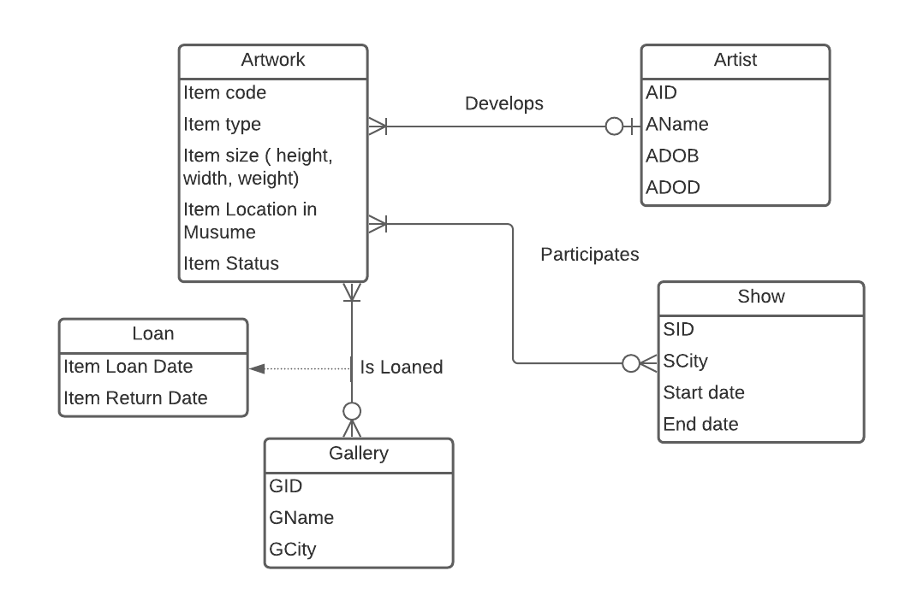

**Fig**2-39(g) ERD

**Primary Keys:** (Item code) from Artwork entity

AID(Artist ID) from Artist entity

SID(Show ID) from show entity

GID(Gallery ID) from gallery entity.

**Relationships and Cardinalities:**

**Artwork and Artist Entities**: One artist develops one or more artwork.

One artwork is developed by 0:1 ARTIST (0 for Unknown ARTIST)

**Artwork and Show Entities:** One artwork may participate in zero or many shows.

One Show can display one or many Artworks.

**Artwork and Gallery Entities:** One artwork is loaned by zero or many Galleries.

One Gallery can loan one or many artworks. Loan date and item return date are specified in the relation**.**

2-39(h)

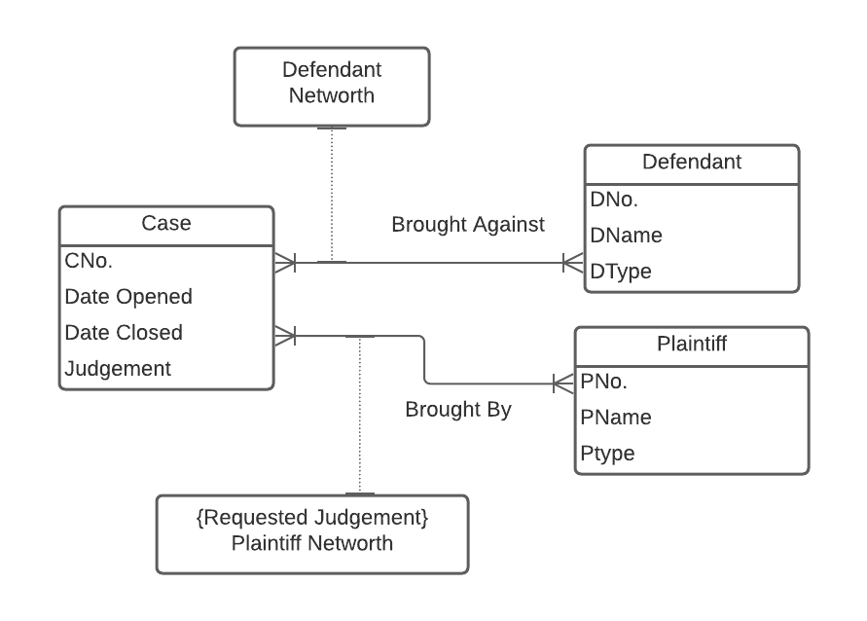

**Fig**2-39(h) ERD

**Primary Keys:** CNo.(case number) from case entity is the PK.

DNo(Defendant number) from defendant entity is the PK.

PNo(Plaintiff number) from plaintiff entity is the PK.

**Relationships and Cardinalities:**

Since Plaintiff Net Worth and Defendant net worth is relevant only at the time of the Case, they are modelled as attributes of the many to many relationship between Case and Defendant, Plaintiff entities.

* **Case and Defendant entities:** There exists a M:N Cardinality between Case and Defendant
* **Case and plaintiff entities:** There exists a M:N Cardinality between Case and Plaintiff

2-39(i)

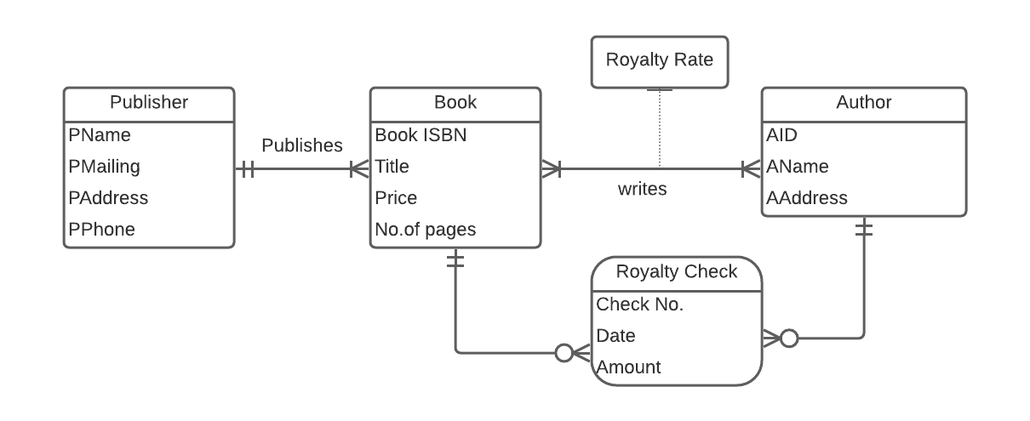

**Fig**2-39(i) ERD

**Primary keys:**

PName (Publisher name) from publisher entity is the PK.

BOOK ISBN from book entity is the PK.

AID(Author ID) from author entity is the PK.

Check number from royalty check entity is the PK.

**Relationships and Cardinalities:**

**Publisher and book entity**:

One publisher publishes one or many books.

One book can be published by one and only one publisher.

**Book and Author entity**:

One author can write one or many books.

One book can be written by one or many authors.

Since there exists M:N relationship between Book and Author, so an associative entity comes into picture. This is “Royalty Check”. It has Check No, Check Date and Check Amount as its various attributes.

====================================================================================================

2-49) Draw an ERD for the following situation. (State any assumptions you believe you have to make in order to develop a complete diagram.) Also, draw a data model for this situation using the tool you have been told to use in your course: The A. M. Honka School of Business operates international business programs in 10 locations throughout Europe. The school had its first class of 9,000 graduates in 1965. The school keeps track of each graduate’s student number, name when a student, country of birth, current country of citizenship, current name, and current address, as well as the name of each major the student completed. (Each student has one or two majors.) To maintain strong ties to its alumni, the school holds various events around the world. Events have a

title, date, location, and type (e.g., reception, dinner, or seminar). The school needs to keep track of which graduates have attended which events. For an attendance by a graduate at an event, a comment is recorded about information school officials learned from that graduate at that event. The school also keeps in contact with graduates by mail, e-mail, telephone, and fax interactions. As with events, the school records information learned from the graduate from each of these contacts. When a school official knows that he or she will be meeting or talking to a graduate, a report is produced showing the latest information about that graduate and the information learned during the past two years from that graduate from all contacts and events the graduate attended.

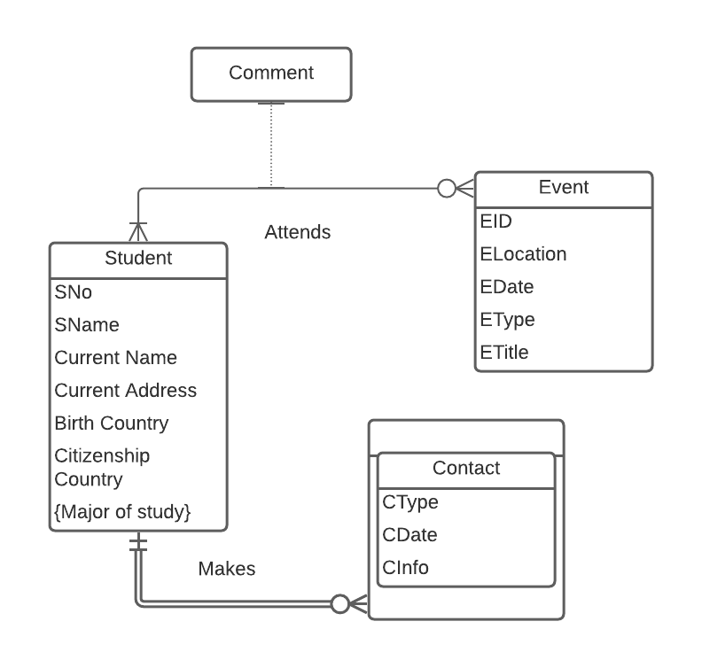

**Fig**2-49 ERD

**Primary Keys**: SNo (Student number) from Student entity

EID (Event ID) from Event entity.

Contact entity is weak entity since it is dependent on student entity.

**Relationships and Cardinalities:**

**Student and event entities:**

One student may attend zero or many events.

One event is attended by one or many students.

**Student and contact entities:**

One Contact can be made by only one Student.

One Student may make many types of contact.

In Student entity Major attribute is multivalued since it is given that each student has one or two majors.

The Comments is an attribute of the ‘Attends’ Relationship. The other attributes that might better describe the Attends Relationship are Date, Duration etc.

Also, since Student and Event has M:N relationship, we can think of an associative entity

“Attendance” that will collect the data and record which student have attended which events.

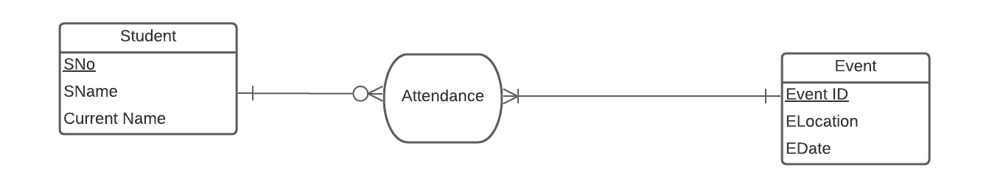

The associative entity “Attendance” will have the required data about which student attended which event. Comments from the students can also be recorded here as an attribute of this entity.

**Relationships and Cardinalities:**

**Student and event entities:**

One student may attend zero or many events.

One event is attended by one or many students.

==========================================================================